
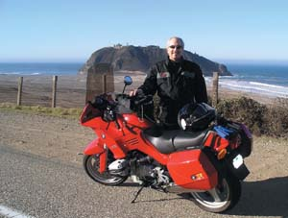
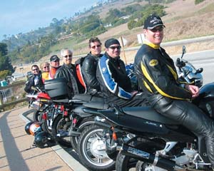
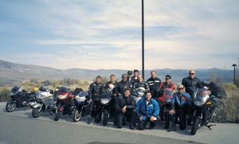
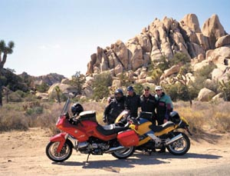
A NICE BIKER GANG
The BMW-St. Francis Motorcycle Charity Ride offers curves with style
IMAGINE A SUNNY AFTERNOON IN THE CAVERNOUS HILLS OF THE SEQUOIA National Forest, the wind brushing past as you hug the curves of the winding road unraveling at speeds that seduce your adrenaline into high gear. Not only does BMW cater its line of motorcycles to this type of terrain, but also to a lifestyle basking in sport and luxury.
Although the German engineered bikes saw its European heyday in the 1920s, it wasn’t until the 1980s that it began to carve a niche for itself in the United States. In two short decades, BMW has developed a steadfast reputation for reliability and comfort — perfect for a quick journey up the California coast.
Now in its 14th year, the BMW-St. Francis Motorcycle Charity Ride draws corporate executives from around the country to participate in an elite four-day ride that begins at the BMW regional headquarters in Ontario to Northern California and back.
A cross section of 60 riders who are attorneys, doctors, entertainment moguls — a long line of who’s who in the corporate world — ride together to raise money for charity and the chance to escape their PDAs, if only for a long weekend.
“This is an opportunity for people all over in different lines of work to hobnob without someone looking for the inside information about their work,” says ride organizer Jim Ryan who recently retired as BMW’s western region senior vice president after 27 years.
In the early days of the ride, the majority of the participants were BMW corporate executives from either the United States or Europe who just wanted an excuse to get out on the open road. As the charity aspect of the ride developed a wider scope, more spaces became available for the trip. In order to be one of the chosen few, you had to know someone already on the inside.
The charity ride continues to be an exclusive event by invitation only. Riders are selected based on seniority. Each rider donates close to $1,000 to take part in the event and the majority of the proceeds go to the St. Francis Medical Center’s “Footprints” program in Lynwood, Calif. to provide shoes and clothing for hundreds of underprivileged children in East Los Angeles. Another portion of the funds raised go to the California Highway Patrol 11-99 Foundation for the families of lost, injured or disabled CHP officers.
Several off-duty CHP officers escort the caravan. Last year the caravan included the original and fully-restored California Highway Patrol car featured in the old TV series Highway Patrol starring Broderick Crawford. Riders follow the 1955 Buick down the coast. The trip is by no means a “roughing it” type of excursion.
Each night the riders stay at posh hotels like the Tenaya Lodge in Yosemite or the Doubletree Resort in Sedona. For instance, when the group rolls through Santa Barbara they stay at the El Capitan Resort in individual cabins sprawled out over a wide canyon overlooking the Pacific Ocean. They cap the night with a private reception on a bluff overlooking the water.
“(The reception) was very formal — we had special wines in banquet halls with live entertainment,” recalls David Kaiser, an entertainment executive who has participated in the charity ride for the past decade and has been racing bikes for most of his life. “Now we just show up in our leathers and have a buffet.”
BMW also makes sure the riders have first class amenities along the way. A cargo van follows the caravan carrying all of the riders’ clothing neatly packed for retrieval upon their destination for the night. The van also holds spare motorcycles and parts in BMW motorcycle enthusiast Tim Lappen takes a break from cruising up the coast on his R1100RS Sports Tourer near the Point Lobos Lighthouse north of Big Sur 3-4-03-Adventure 2/16/04 1:47 AM Page 82 case someone blows a tire, experiences mechanical problems, or takes a corner the wrong way.
“(A BMW motorcycle) is the finest bike you can buy,” Kaiser says. “It’s the difference between a propeller plane and a Lear jet. (The bike) is extremely well balanced.”
Although many of the riders like Kaiser have gone to racing school and know how to take the calculated risks, others are a little more cautious.
Some, like Ryan Autrey, who is married with two young children, says this is one of the rare occasions he is sanctioned to go out and live a little dangerously.
“When you’re on a bike, the day to day pressure evaporates,” Autrey says. “You’re so focused that when you finish you think, ‘Wow, I didn’t think of work once.’”
When it comes to three-digit transportation, there’s nothing like ripping down Route 33 through the Ojai Mountains, a motorcycle rider’s paradise. The misconception, however, is that they ride travel at breakneck speeds everywhere they go.
“I like riding really fast and we go generally 100 miles per hour,” says Chris Clevely, who grew up riding dirt bikes in Lancaster, Penn. “It sounds fast to people, but it only sounds criminal because they think of it down their residential streets.” Once the chariots are returned, the leather comes off and the suits and ties go back on. In the end, the quiet bonfire on the beach and the camaraderie between riders remains.
The experience is like no other, says Tim Lappen, chairman of the Family Office Practice Group at the law firm of Jeffer, Mangels, Butler & Marmaro and another organizer of the charity ride. “It’s a very visceral experience,” Lappen says. “You can feel the temperature change and the smells change. Unlike a car, you can feel the wind.”
— Cindy Yoshiyama

© Copyright 2004 Brentwood Magazine

